Cromdale House
PH26 3LQ, Cromdale, Grantown on Spey, Moray
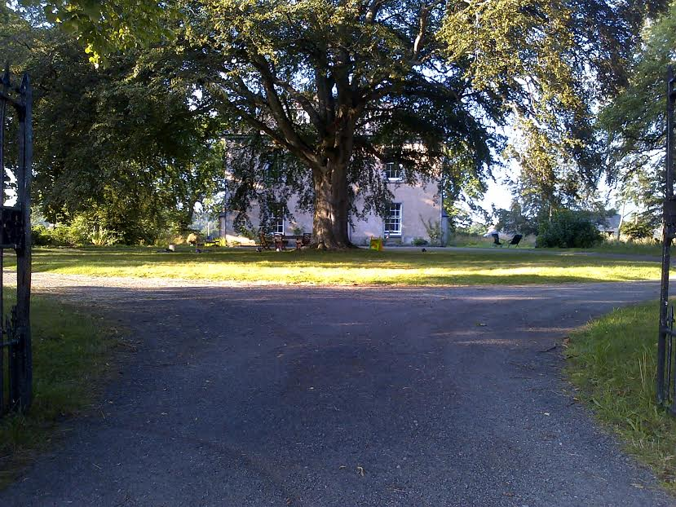
Speyside Way walkers refreshment, camping and chill out place

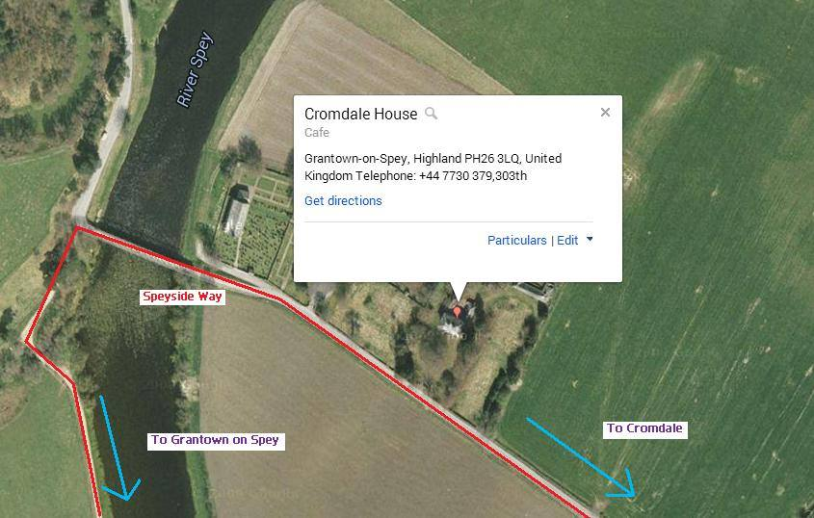

Cromdale House is an ideal place for Speyside Way Walkers to stop and have a refreshing drink or hot cup of tea/coffee. We also offer home made scones, or home made deli. Beautiful garden for campers is available from April to October. Baby and animal friendly.
Web: www.facebook.com/CromdaleHouse
Email: erikagiffardmoore@gmail.com, charles@sterlinghanover.com
Tel: 07506358734 or 07730379303

