This access statement does not contain personal opinions as to our suitability for those with access needs, but aims to accurately describe the facilities and services that we offer all our guests/visitors.
Access Statement for Kirkennan Woodsedge

Introduction
Kirkennan Woodsedge is ideal for those that want a peaceful holiday retreat in the heart of Dumfries & Galloway. It is set on the peaceful Kirkennan Estate with landscaped gardens, woodland and a Victorian walled garden.
Woodsedge sleeps up to 5 and has 3 bedrooms - with all rooms being on the ground floor. The twin room has one adjustamatic electric bed which adjusts the height and the head end. There is a wetroom with step free level entry shower with the option of a shower stool or chair, and a toilet with grab rail to the right when seated. A booster insert for the toilet is available if required. The sitting room/diner has an electric riser/recliner chair.
There is level entry into the front door. There is a small step down from the sitting room or kitchen into the enclosed rear garden - a portable ramp is provided or level access is available through the gate.
Woodedge has been converted from the previous stable block, and whilst care has been taken to make it as accessible as possible, some doorways are narrower than would be the norm in a purpose built building. Please take careful note of door measurements.
We welcome dogs who can be let off the lead in the nearby 14 acre Jock's wood. You can borrow a mobility scooter for use in Kirkennan grounds.
We look forward to welcoming you. If you have any queries or require any assistance please phone 01556 600438 or email kirkennancottages@gmail.com.
Pre-Arrival
- For full details and maps of how to reach us please see the directions section of our website. Alternatively, you can plan your journey by car or public transport using www.transportdirect.info; simply enter your postcode and ours, which is DG7 1PE to get directions.
- You can pause your car right outside the door of Woodsedge to unload, parking is round the corner in front of the garage (about 7m)
- The nearest railway station is Dumfries which is 16.4 miles away. Taxis are available at the station. If you require an accessible taxi this can be booked in advance from http://www.herdsmanstaxis.co.uk/.
- The Estate roads are very quiet and easy to access. The nearest village is Palnackie, about 1km away, however there is no footpath along this country road.
- You can arrange for shopping to be delivered in time for, or shortly after, your arrival, please let us know your requirements when booking.
- Information on Woodsedge and this Access Statement are available in larger print on request.
Key Collection, Welcome and Car Parking
- We will make arrangements with you for the key to be available at Woodsedge on arrival.
- Parking is available for 2 cars round the corner of Woodsedge
- There is no dropped curb
- The parking area has a macadam surface
- The parking area has lighting that can be turned on at night.
Entrance to Property
- The front door is 72.5cm wide with a small lip.
- There is plenty of turning space within the front entrance hall.
- The entrance has a light that can be turned on at night.
- The floor covering inside the entrance is short pile carpet. There is an entrance mat that can be removed on request.
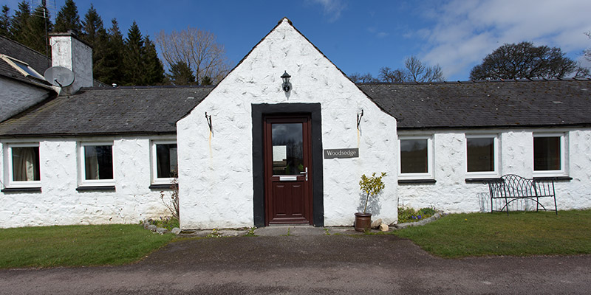
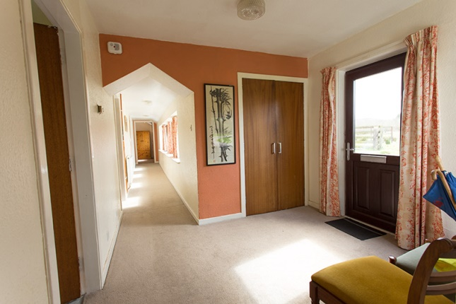
Halls, Stairs, Landings, Passageways
- There are no stairs - Woodsedge is all on one level
- The floor covering is short pile carpet throughout except in the kitchen which is lino tiles.

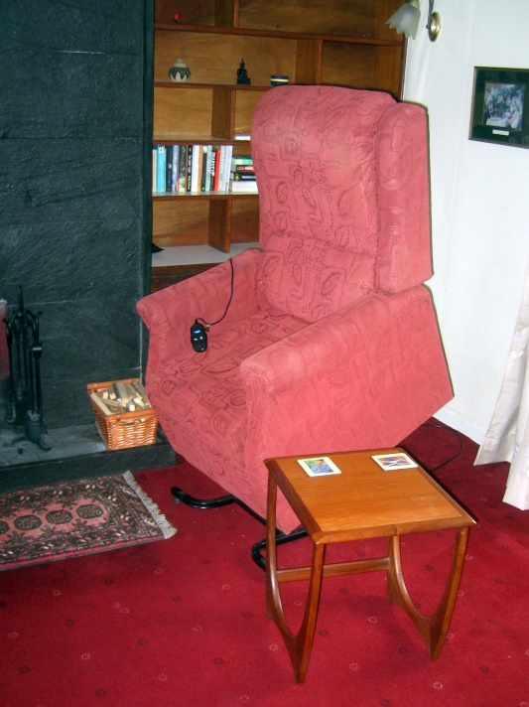
Sitting Room/Lounge
- The sitting room is on the ground floor with level entry from the hallway
- The door opening from the hall to the lounge is 71.5 cm
- The door opening from the lounge to the garden is 81cm. There is a small step down (approx. 5cm) - a portable ramp is provided.
- The room has a mixture of seating including an electric riser/recliner chair, a sofa, an armchair, and dining chairs.
- Furniture can be moved
- There is digital television with remote control and a DVD player
- Lighting is natural daylight. At night there is overhead lighting, side lighting and a standing lamp
- The flooring is short pile carpet with a rug in front of the fire that can be removed.
Dining Room
- The dining area is situated in one side of the sitting room with level entry from the hallway (which has level entry from the kitchen)
- The door openings to the dining/sitting room is 71.5 cm
- There is a serving hatch between the kitchen and the dining area
- The dining table is moveable. It is oval with 4 legs. It can be extended if required.
- Chairs (all moveable) - chairs with padded seats 3 with no arms and 2 with arms. For smaller parties spare chairs can be placed in the hallway out of the way.
- Lighting is natural daylighting with a standing lamp by the table.
- Flooring is short pile fitted carpet
Kitchen
- The kitchen is on the ground floor with step free, level access from the hallway.
- The door opening to the kitchen from the hallway is 81cm
- The door opening from the kitchen to the garden is 81 cm. There is a small step down (approx. 5cm), a portable ramp is provided.
- The door of the oven drops down.
- A fridge freezer is available.
- A perch stool is provided

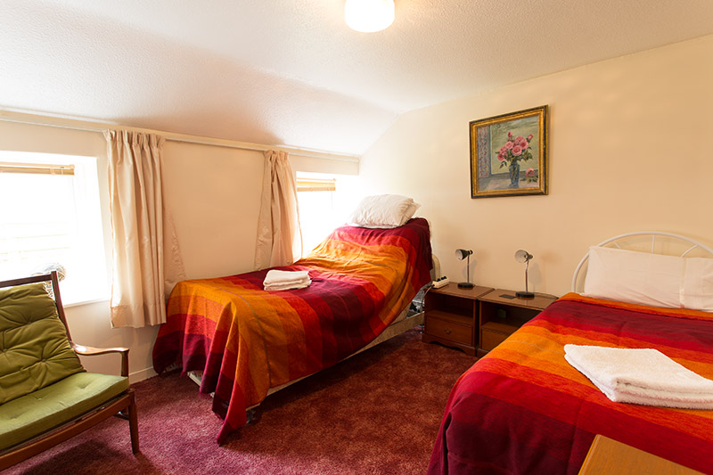
Bedrooms and Sleeping Areas
- All bedrooms are on the ground floor with level access from the hallway
- There is a twin room with an adjustable electric bed (height adjusts and head end raises). The door to this room is 81 cm wide
- There is a double room. Door width is 74cm
- There is one single room. Door width is 73 cm
- Furniture can be removed or re-arranged on request.
- All beds have bedside lamps
Bathrooms, Shower-rooms and Toilets
- There is one wet room, which is on the ground floor and has level access
- The door width is 75.5cm (note this is incorrectly given as 73.5cm in the diagram below)
- The wet room has a level entry shower, a wash basin and a toilet
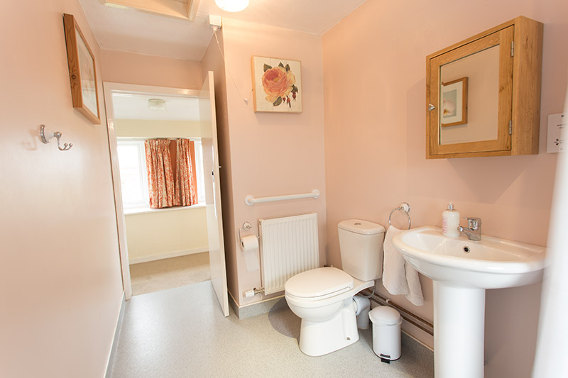
- There are grab rails by the shower in contrasting colours and to one side of the toilet (on the right when seated)
- There is a choice of shower stool or shower chair (or both)
- A toilet insert is available to raise the seat level.
- The wet room has non slip flooring.
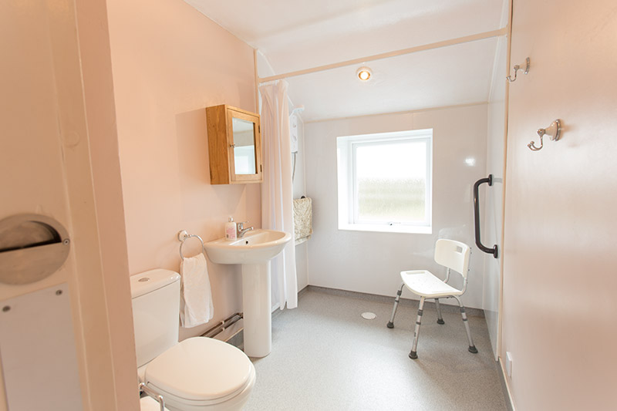
Garden
- Woodsedge has a small private enclosed garden to the rear
- This is level and has a paved area, a flower bed and a lawn
- Garden furniture is provided.
- Guests are also welcome to enjoy Kirkennan Estate's garden, and we provide a mobility scooter to facilitate this. This can be used on the Estate roads, which are tarmac. The paths in the walled garden are gravel; some people have successfully used the mobility scooter here also. It will not cope with the uneven turf paths in Jock's wood.
- There is seating in the terrace at the top of the walled garden – there are two steps up to the terrace.
- There is a picnic bench in the grove at the centre of Jock's wood.
- There is a bench in Jock’s wood overlooking the river.
- All paths in Jock’s wood are unpaved and uneven.
- Dogs can be let off the lead in Woodsedge’s own garden and in Jock’s wood. In other areas of the Estate we request that they are kept on lead.
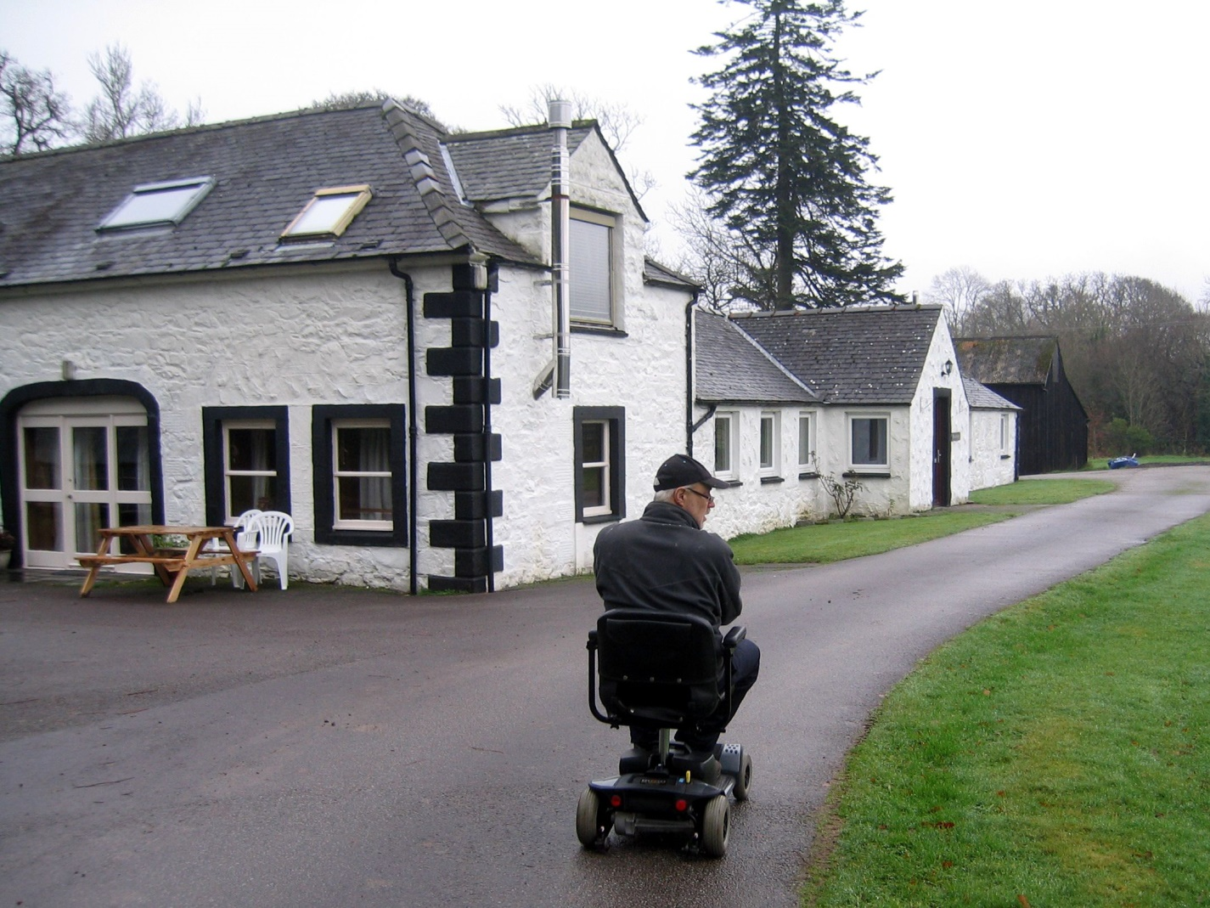
Additional Information
- All dogs, including assistance dogs, are welcome
- The mobile reception can be poor. Best is vodaphone, followed by EE. O2 is particularly bad.
- The nearest general hospital with an A&E unit is in Dumfries.
- Our website has a page with information about accessible local attractions.
Future Plans
- We welcome suggestions on how we can improve the accessibility of Woodsedge and our other properties, within the constraints of them being old buildings.
- We also welcome suggestions on what additional information would make this access statement more useful.
Contact Information
Address (Inc postcode): | Kirkennan Woodsedge, Kirkennan Estate Cottages Palnackie Castle Douglas Dumfries & Galloway DG7 1PE
Telephone: | 01556 600438
Email: | kirkennancottages@gmail.com
Website: | www.kirkennancottages.co.uk
Hours Of Operation: | For non-emergencies please feel free to telephone us or knock on the door any day 9am - 9pm (in emergencies you can call/knock any time). At other times you can contact us via email. The cottages are open all year.
Local Equipment Hire: | Dalbeattie Day Care Centre (01556 611839) loan wheelchairs in return for a donation. If you cannot collect the wheelchair yourself due to time of arrival or space in the car it might be possible for us to collect it and have it ready for you on arrival. This will depend on our other commitments and should be requested when booking.
Local Accessible Taxi: | Herdsmans Taxis, Castle Douglas http://www.herdsmanstaxis.co.uk/  01556 502 551

